Home Screen

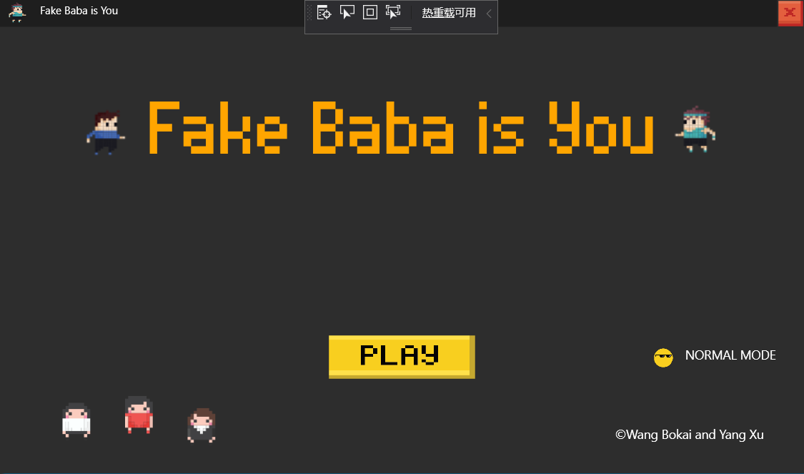

Click here to change the mode

TextBox Mode

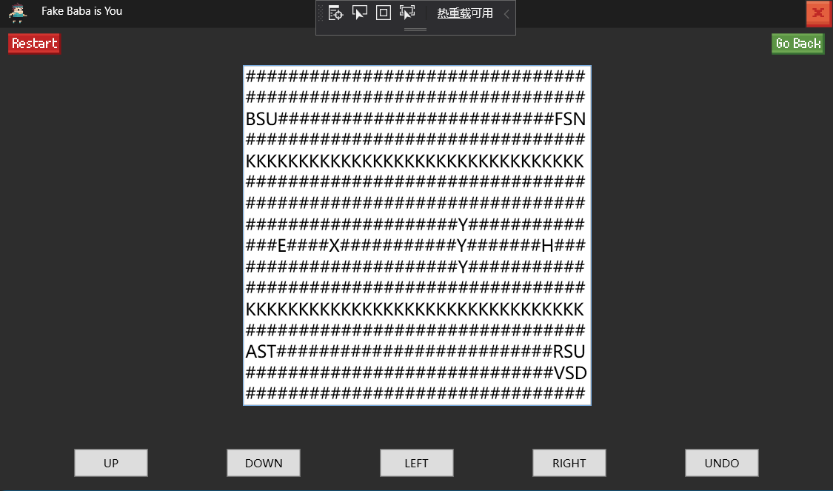

|  |  |  |  |  |  |  |  |  |  |  |  |
| --- | --- | --- | --- | --- | --- | --- | --- | --- | --- | --- | --- |
| Symbol | B | S | U | F | N | A | T | R | U | V | D |
| Meanning | Baba | Is | You | Flag | Win | Wall | Stop | Rock | push | Skull | defeat |
| Picture | X |  |  | H |  | K |  | Y |  | E |  |

Level Choose Page 1

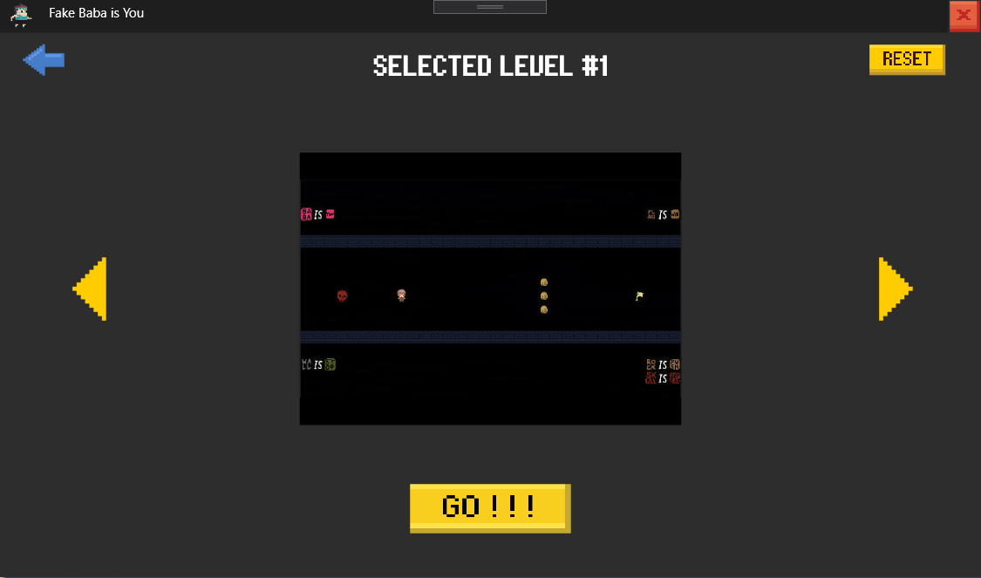

Level Choose Page 2

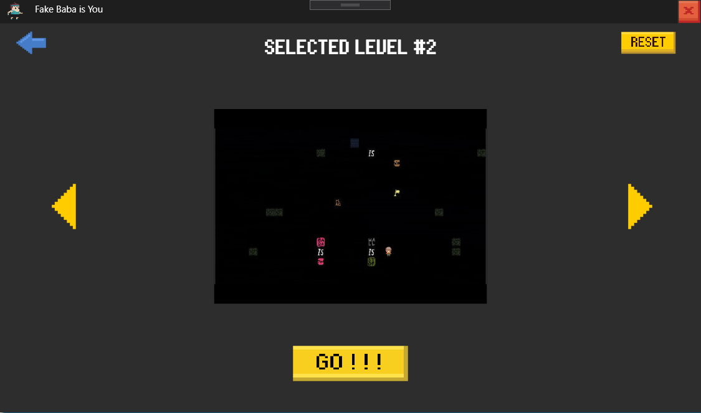

Game Level 1 Page

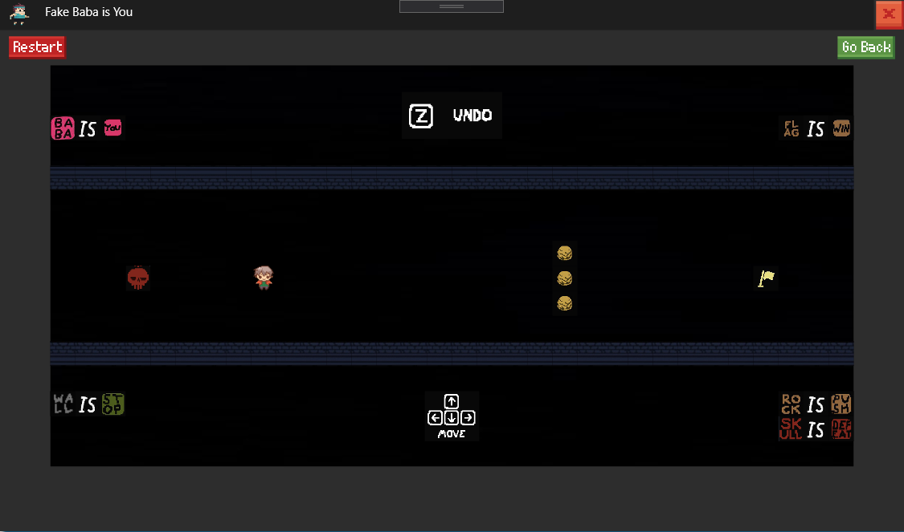

Game Level 2 Page

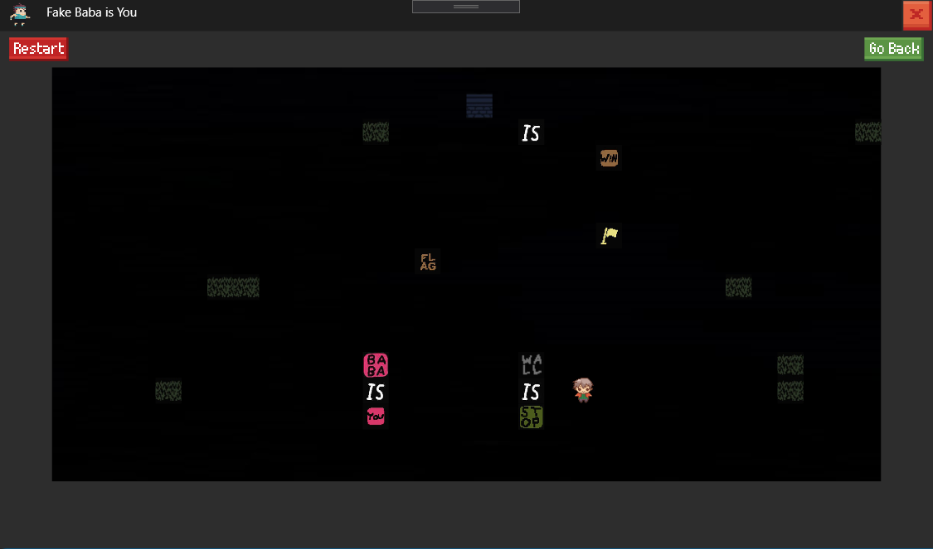

Fail Page 1

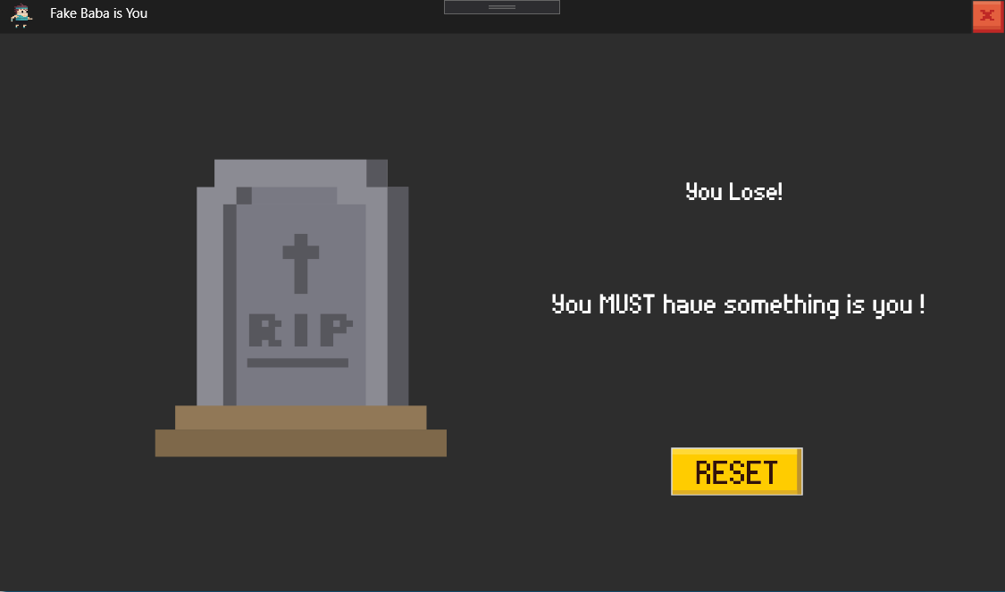

Fail Page 2

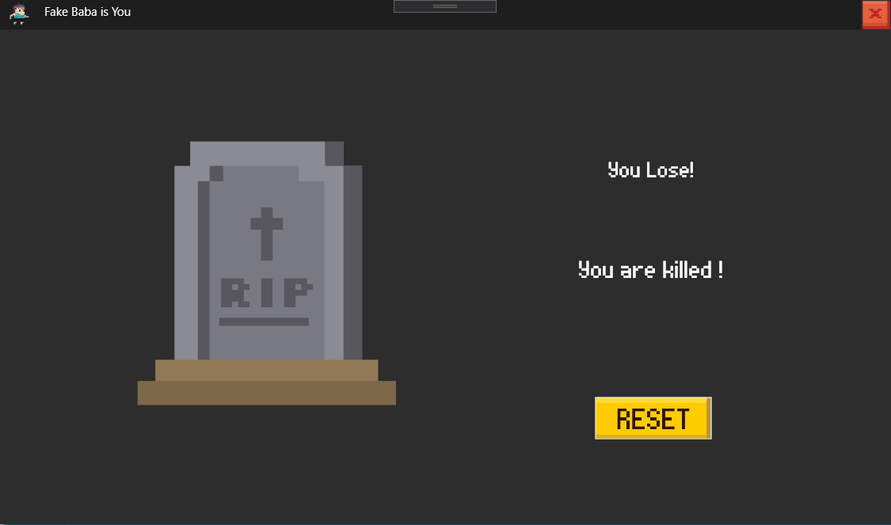

Congratulation Page 1

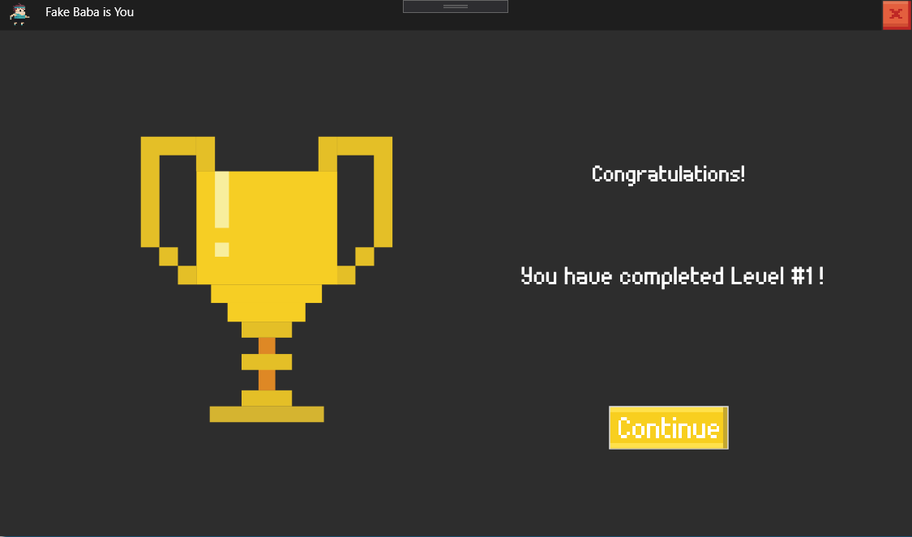

Congratulation Page 2

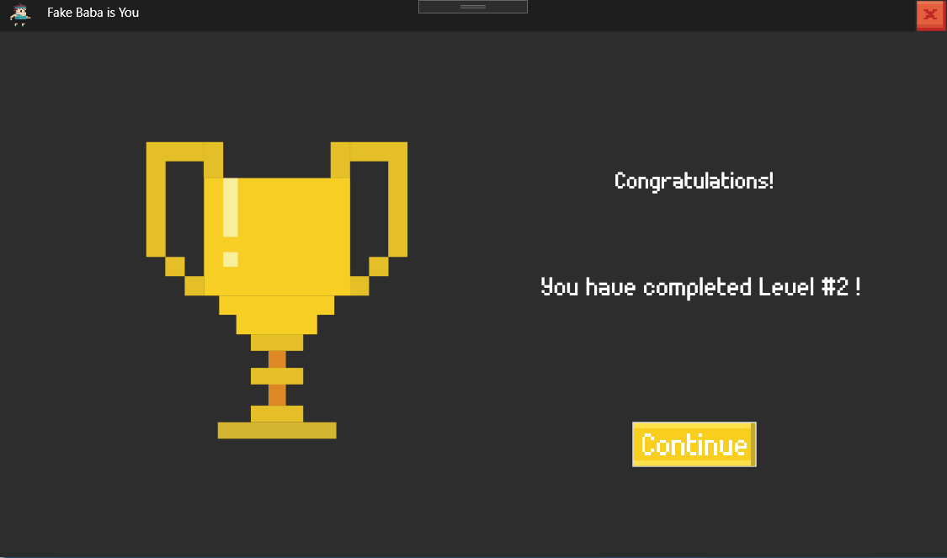

End Page

